HANDBOOK

Zamzam Water: Sacredness, Consumption

and Environmental Responsibility

Interreligious Education for Sustainable Development (irBNE)

Amina Boumaaiz

1. Introduction: Aims and context
Water is one of the central symbols of religious traditions worldwide. It represents life, purification, blessing and divine closeness. At the same time, water is one of the most threatened resources of our time and lies at the heart of global ecological crises. This dual significance – as both a spiritual symbol and an endangered resource – makes water a particularly suitable topic for linking religious education and sustainable development.
Using the example of Zamzam water, this handbook develops an approach to linking religious perspectives, ecological issues and interfaith dialogue processes in higher education. It is aimed at teachers in teacher training as well as those involved in interfaith educational work.

2. Zamzam water as an example of a didactical approach
In the Islamic context, Zamzam water holds profound religious significance. Its origins lie in the story of Hagar (Hāǧar) and her son Ishmael: in a situation of existential distress, the spring gushes forth as a divine response to both trust and despair. To this day, Zamzam is understood as a sign of divine mercy, provision and closeness.
The spiritual practice of consciously drinking Zamzam water, combined with a personal prayer (duʿāʾ), points to a profound dimension of religious experience. Zamzam is thus not merely a physical commodity, but a symbolically highly charged component of Islamic devotional practice.
It is precisely this strong symbolic significance that makes Zamzam water a particularly suitable starting point for didactic reflection: for today it also stands at the crossroads of modern consumer structures.

3. Between sacredness and commercialisation
Nowadays, Zamzam water is bottled, transported and distributed on a massive scale across the globe. What was originally understood as a freely accessible source of divine grace is now often presented as a consumable product in plastic bottles, integrated into global markets.
This development raises fundamental questions:
• How does the perception of the sacred change as a result of its packaging and marketing?
• What tension arises between spiritual significance and economic exploitation?
• To what extent does the mass use of single-use plastic contradict religious responsibility towards creation?
Examining Zamzam water makes it possible to make these questions tangible and relevant to everyday life. The combination of religious symbolism and visible environmental issues creates a productive tension that is central to educational processes.

4. Environmental ethical perspectives in a religious context
From an environmental ethics perspective, the question arises as to humanity’s responsibility in the management of natural resources. In Islamic thought, this responsibility is closely linked to the concept of khalīfa (human stewardship on earth). Humanity is not the owner of creation, but rather its trustee (amâna).
Against this backdrop, the handling of Zamzam water takes on a new dimension: when a resource regarded as sacred is consumed in ways that cause long-term ecological damage, an ethical tension arises between religious practice and ecological responsibility.
Engaging with this tension makes it possible to interpret religious traditions not statically, but dynamically – in dialogue with current global challenges.

5. Interfaith compatibility

The concept of ‘holy water’ is not confined to Islam, but is found in various religious traditions, in which water is understood as a fundamental element of creation and as a symbol of life, purity and divine grace.
These shared interpretations open up a space for interreligious dialogue that focuses not primarily on differences, but on shared ethical perspectives. At the heart of this are questions concerning humanity’s responsibility towards creation: How is water interpreted religiously as a life-giving resource? What normative consequences does this have for the mindful and sustainable use of natural resources?
A comparative perspective makes it clear that, despite their respective theological peculiarities, different religious traditions agree on the concept of creation entrusted to humankind. From this, a common ethical stance can be derived which understands the protection and preservation of the natural foundations of life as a religiously grounded responsibility.

6. Didactic principles
Introduction to this part: The concept developed here is based on four key pedagogical principles that are closely interlinked and complement one another in the learning process. The following description illustrates how a concrete, real-life approach can give rise to a reflective, dialogical and responsibility-oriented learning process.

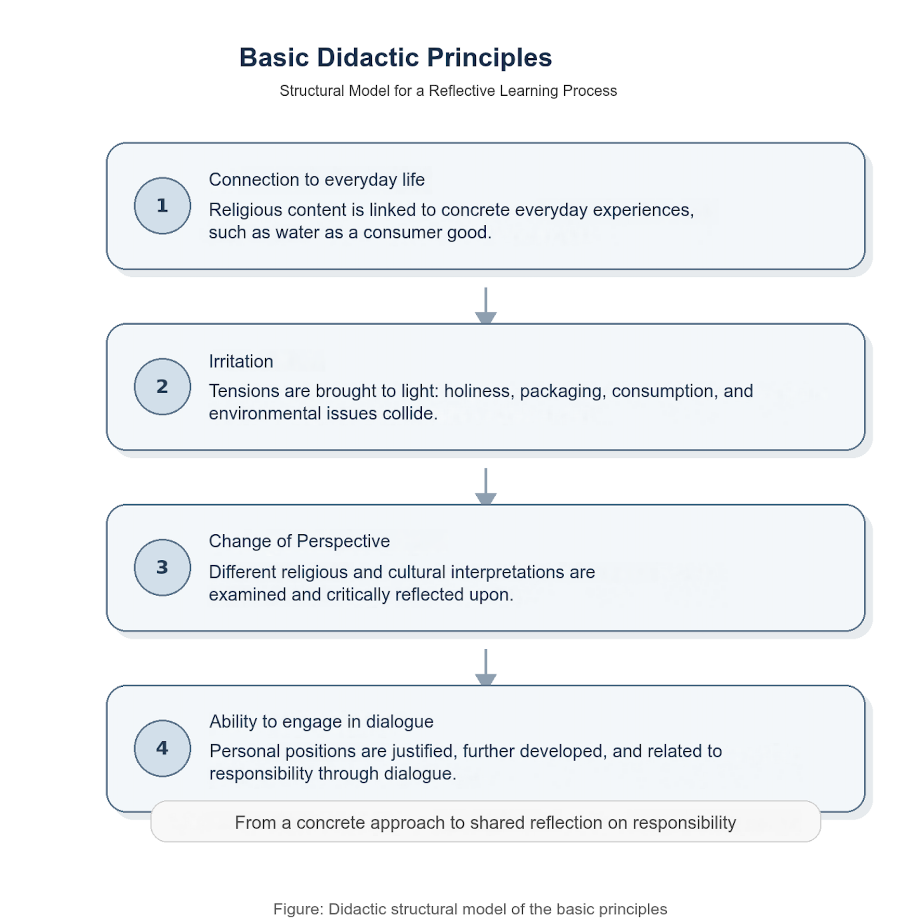
Source: own illustration
These four principles should not be understood in isolation, but together form a pedagogical approach: the starting point is the learners’ lived experience; reflection is triggered by provocation; shifts in perspective broaden interpretation; and the ability to engage in dialogue enables a reasoned examination of religious, environmental and social responsibility.

7. Structure of a viable learning process
Based on these principles, a typical learning process can be outlined, one that can be flexibly adapted: It begins with a visual or narrative stimulus that raises questions and captures attention. This is followed by a phase of exploring the content, in which religious contexts and meanings are clarified. The insights gained are then explored in greater depth through analytical and dialogical formats, such as group work or discussion. The process concludes with a reflective phase in which individual positions are developed and related to specific contexts of action.
8. Implications for teacher training
This approach is particularly relevant to teacher training. Students not only learn the subject matter, but also develop the skills to apply it in educational contexts. They are equipped to:
• link complex topics such as sustainability and religion,
• address controversial issues in the classroom,
• design interfaith learning processes, and
• encourage pupils to engage in critical reflection.
In this way, the concept contributes to the professional development of trainee teachers in the field of values-based and dialogue-oriented education.
9. Religious education in the context of global challenges
The example of Zamzam water illustrates how religious education can contribute to addressing global challenges. It highlights that spirituality and environmental ethics are not separate spheres, but are interconnected in many ways.
When religious traditions engage in dialogue with issues of sustainability, an educational approach emerges that is both identity-forming and future-oriented. Interfaith education for sustainable development thus becomes a central component of an education system geared towards responsibility, reflection and collective action.

10. Methodological and teaching implementation, using group work as an example
A central component of the teaching approach developed here is the use of open, reflective group formats. These enable students to explore complex areas of tension independently and to relate different perspectives to one another.
A particularly suitable approach involves forming thematically focused working groups, each dedicated to a specific aspect of the tension between sacredness, consumption and environmental responsibility.
The group concepts developed in this context (see Materials: Group Work 1 and 2) provide examples of how such learning processes can be implemented in practice.
11. A didactic framework for working in groups
Einstieg (Irritation)
→ Konfrontation mit Bildern/Materialien (z. B. Zamzam in Plastikflaschen)
Erarbeitungsphase (Gruppenarbeit)
→ Bearbeitung unterschiedlicher Perspektiven (religiös, ethisch, didaktisch, interreligiös)
Vertiefung (Austausch)
→ Präsentation und Diskussion der Gruppenergebnisse
Reflexion (Transfer)
→ Übertragung auf Unterricht und eigene Haltung
Introduction (confrontation)
→ Confrontation with images/materials (e.g. Zamzam in plastic bottles)
Development phase (group work)
→ Examination of different perspectives (religious, ethical, educational, interfaith)
Deepening (discussion)
→ Presentation and discussion of group findings
Reflection (transfer)
→ Application to the teaching process

The educational function of group work
Working in groups fulfils several key functions:
• it opens up a variety of perspectives
• it promotes dialogue-based learning
• it encourages critical reflection
• it creates space for individual interpretations and viewpoints
Particularly in the context of interfaith education, it enables different religious approaches to be brought into dialogue with one another and helps to identify shared ethical issues.
Teaching process model and group work
CONFRONTATION
The starting point is a sense of unease in which the religious significance of water is confronted with contemporary challenges such as consumerism and environmental responsibility.
↓
DEVELOPMENT
Through group work, students explore the topic from multiple perspectives (religious, environmental ethics, pedagogical, interfaith) and develop initial interpretations.
↓
EXCHANGE
The results are presented and discussed in a plenary session. Different perspectives are explored through dialogue.
↓
REFLECTION & APPLICATION
Students reflect on their findings and apply them to potential teaching contexts and their own pedagogical approaches.

The model illustrates the process of group work: starting with a thought-provoking question, followed by in-depth discussion in small groups, a plenary discussion, and concluding with reflection and the application of these insights to the classroom.
Group work – didactic implementation
The following group work is designed to explore in depth the tension between sacredness, consumerism and environmental responsibility. The aim is to bring together different perspectives and use them to develop teaching approaches for religious education.
Group work serves as a learning method, a tool for reflection and, at the same time, a model for future lesson planning. It enables students to explore complex interrelationships, examine them through dialogue and apply them to educational contexts.

Group 1: Zamzam: Between sacredness, consumerism and the environment
Key question
How does modern packaging alter perceptions of holiness – and how can this be addressed in religious education?
Activities
1. Religious perspective
• What significance does Zamzam water hold in Islam?
• What symbolic role does water play in religious contexts?
• How does packaging affect spiritual perception?
2. Environmental ethics perspective
• What responsibilities arise in the handling of sacred resources?
• How can faith be linked to environmental ethics?
• What does sustainability mean from a religious perspective?
3. Didactic perspective
• Which methods combine spirituality and environmental protection?
• Which approaches are suitable (e.g. images, symbols, role-play)?
• Which questions promote reflection?
4. Interreligious perspective
• Are there comparable practices in other religions?
• Which shared values can be identified?
• How can comparison promote understanding?

Group 2: Sacredness in the context of marketing – between spirituality, commerce and responsibility
Key question
What happens when religious symbols are commercialised – and how can this be addressed in the classroom?
Activities
1. Religious perspective
• What significance do religious symbols have today?
• How does commercialisation alter their impact?
• What does authentic spirituality mean?
2. Environmental ethics perspective
• What ecological consequences arise from mass production?
• Is the packaging of sacred objects problematic?
• What responsibility do believers have as consumers?
3. Didactic perspective
• How can critical thinking be encouraged in the classroom?
• What materials are suitable?
• Which methods support the formation of judgement?
4. Interreligious perspective
• Are there similar phenomena in other religions?
• What conflicts or opportunities arise?
• What common ethical positions can be identified?
Significance for teacher training
This methodological approach is of particular importance for teacher training. Students not only learn the subject matter, but also gain an understanding of how such topics can be taught effectively.
In this context, group work serves as:
• a learning method
• a tool for reflection
• a model for future lesson planning
Transfer to School Contexts
An essential aim is to apply the approaches developed in the seminar to school settings. The structure of the group work can serve as a model for religious education, particularly at lower secondary level.

Image materials and Articles
Please make sure that all images are provided with proper source information and references.

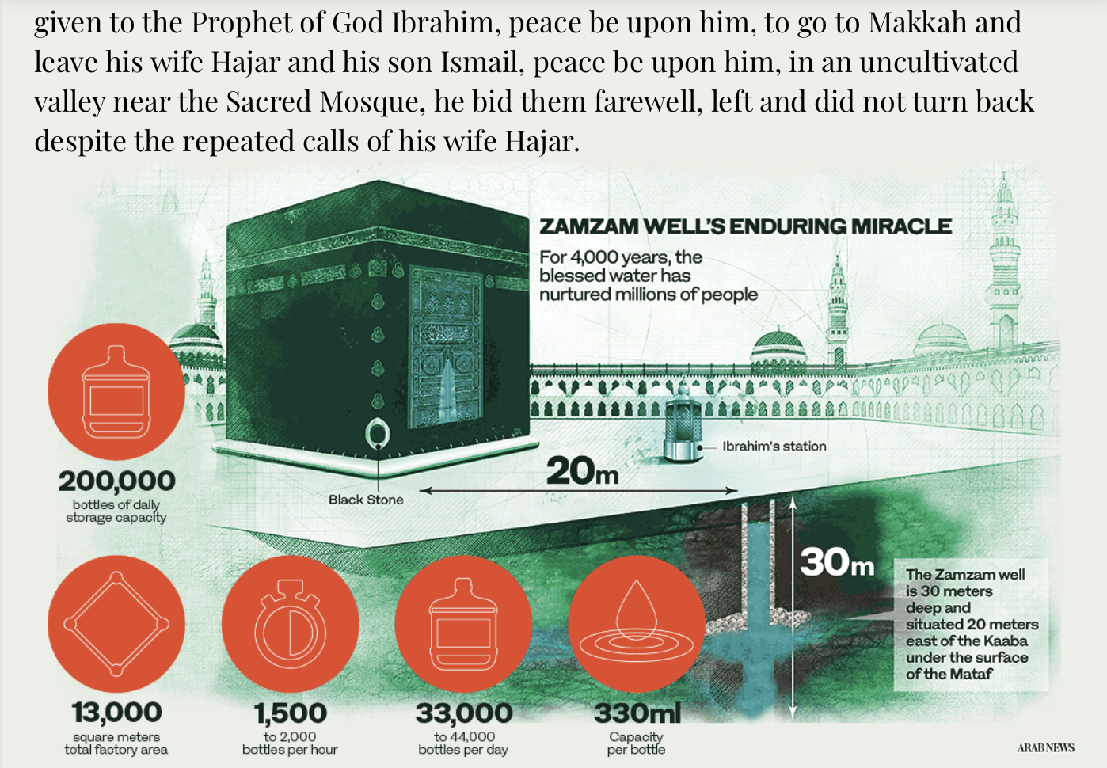
Abbildung X: Infografik zum Zamzam Water Project. Quelle: Arab News (2022), „Makkah’s Zamzam water production melds ancient history with modern technology“, URL, abgerufen am 06.05.2026.
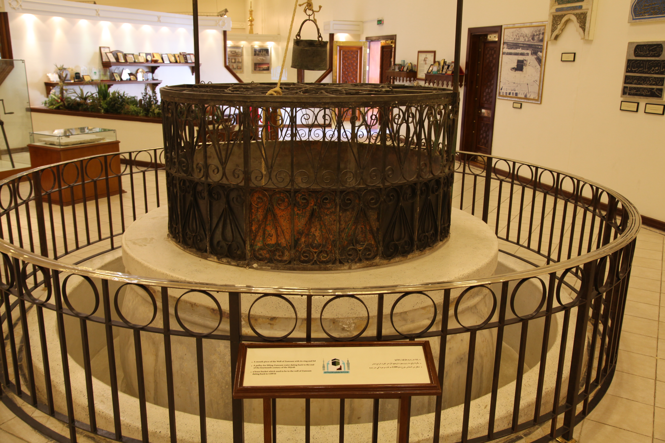
By Mohammad Bahareth - Flickr: بئر زمزم الأثري, CC BY-SA 2.0, https://commons.wikimedia.org/w/index.php?curid=33477990


By Khalili Collections, CC BY-SA 4.0, https://commons.wikimedia.org/w/index.php?curid=97920328

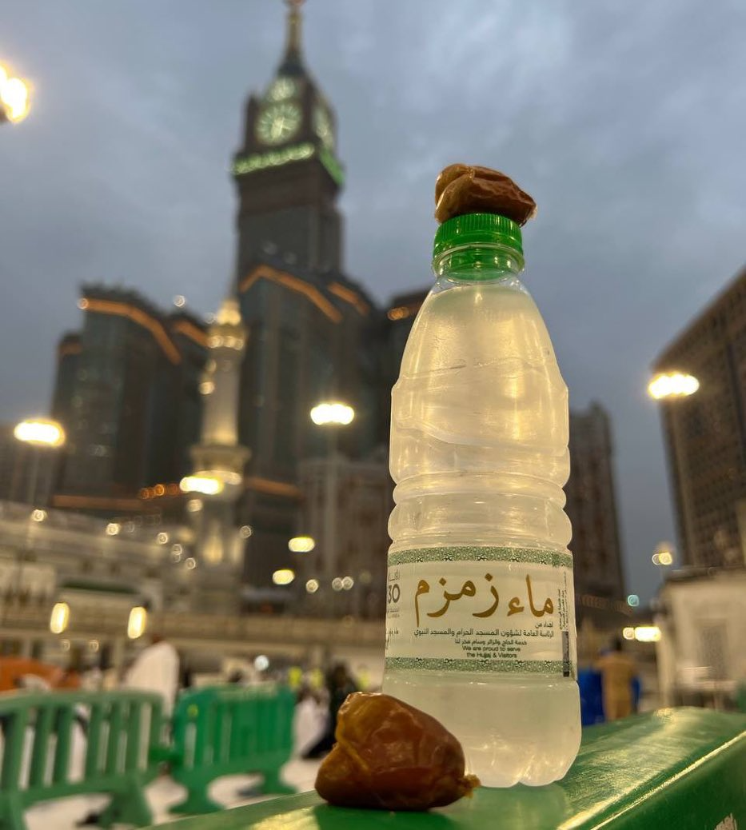
Source: Qamar, Mohammad Anees: Zamzam water bottle with dates in front of Abraj Al Bait Clock Tower, Mecca, via Wikimedia Commons, licensed under CC BY-SA 4.0, available at:
https://commons.wikimedia.org/wiki/File:Zamzam_water_bottle_with_dates_in_front_of_Abraj_Al_Bait_Clock_Tower,_Mecca.jpg (accessed: May 5, 2026).
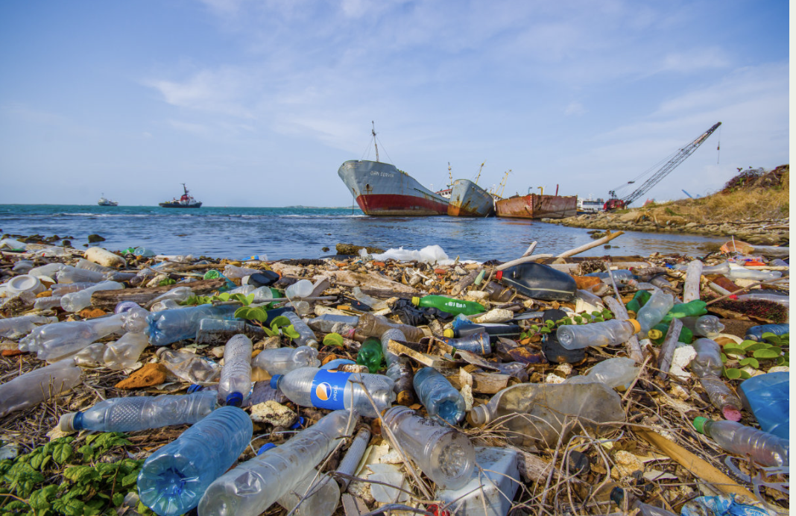
Image: Plastic waste on a beach because of global consumption patterns
Source: Shutterstock (stock image), cited from: Manal Al-Barakati, Why Saudi Arabia is ditching plastic bottles in favor of tap water, Arab News, 28.02.2025, https://arab.news/meu38 (Zugriff am: 05.05.2026)

The commercialisation of religious products is also evident in online retail. Zamzam water is sold internationally via platforms such as eBay in a variety of packaging and sales formats.
An example of the digital marketing of Zamzam water via international online retail platforms.
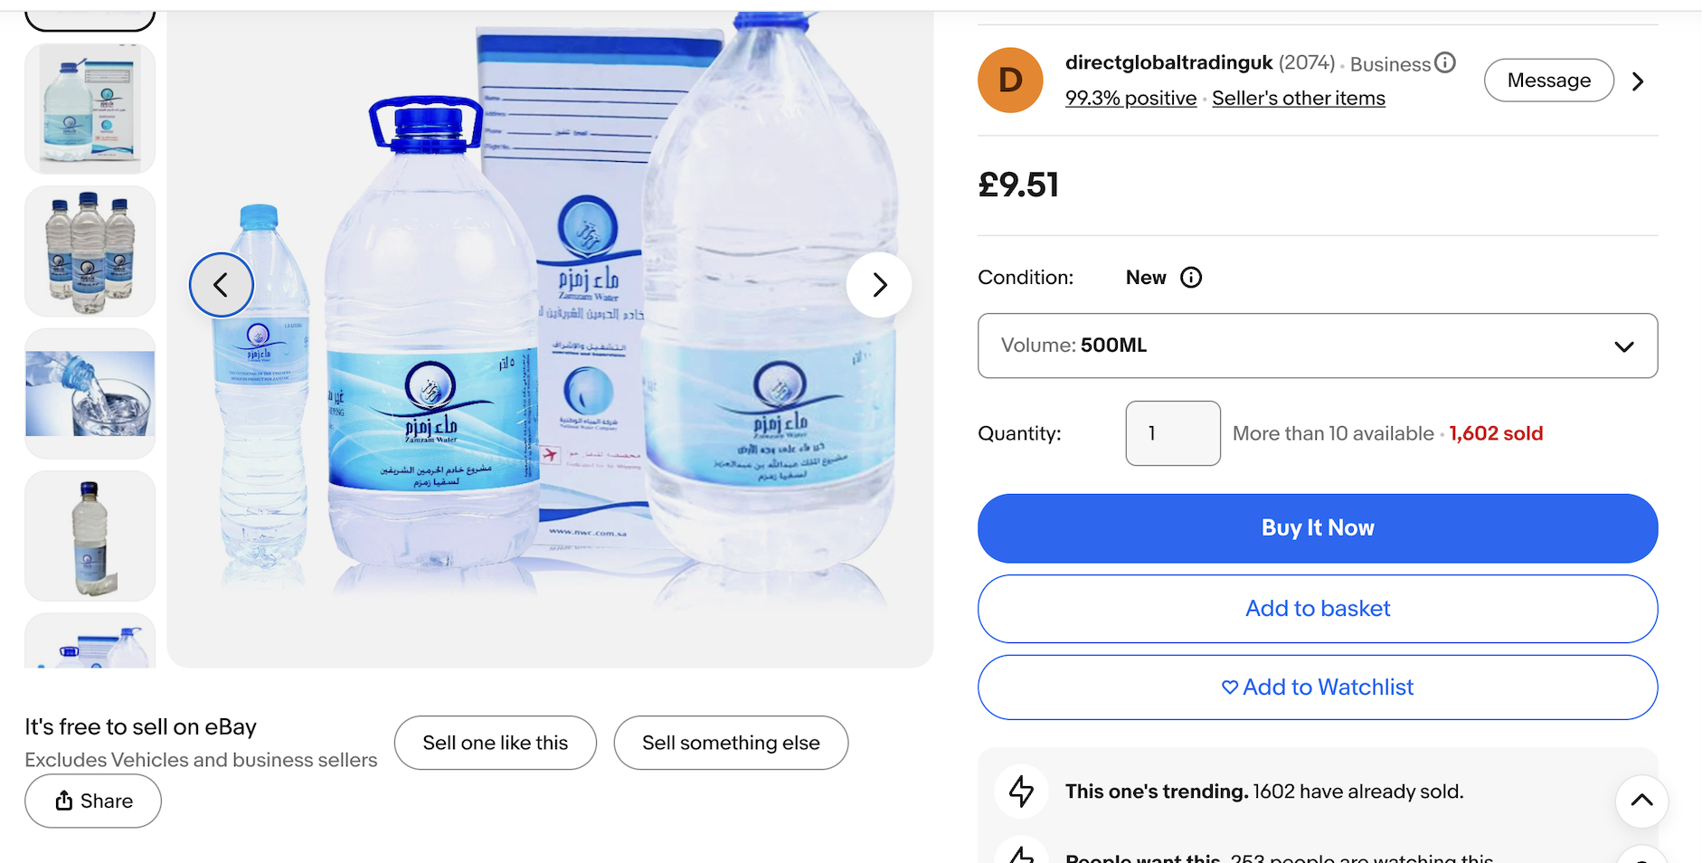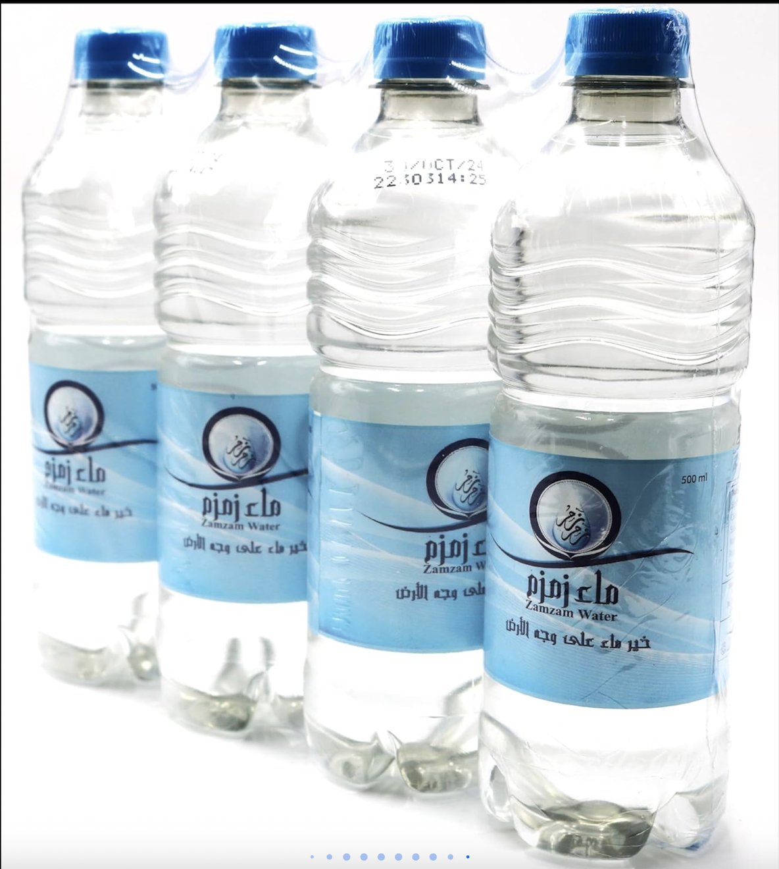
Source: eBay UK, „Zamzam Water Zam Zam Mecca Makkah 100% Original Natural“,
abrufbar unter:https://www.ebay.co.uk/itm/235286049815 (accessed on 06.05.2026).

Article: Practical Solutions for a Waste-Free Hajj:
As Hajj season arrives, the waste crisis in Makkah necessitates eco-friendly practices: https://muslimclimatewatch.com/practical-solutions-for-a-waste-free-hajj/?utm_source=chatgpt.com

The photograph highlights the environmental challenges posed by large-scale pilgrimages, particularly those caused by single-use plastics and water bottles. At the same time, there is a growing number of initiatives promoting a more sustainable and environmentally friendly Hajj (‘Green Hajj’), which call for waste reduction, recycling and responsible consumption.

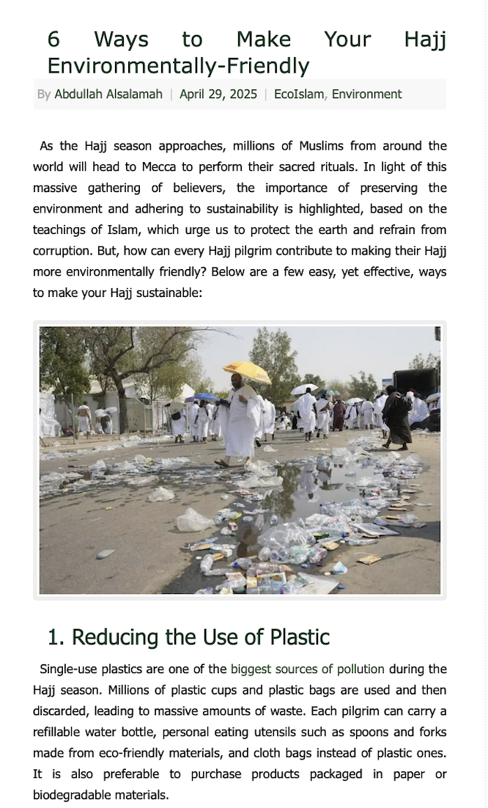

Source: EcoMENA, „6 Ways to Make Your Hajj Environmentally-Friendly“, 29.04.2025,
https://www.ecomena.org/eco-friendly-hajj/
(accessed on 06.05.2026).

