Image credits
Essential for uploading:
Image | Sources | Licence
Zamzam bottles | e.g.Wikimedia Commons | CC-locence
plastic waste | Unsplash / Pixabay | free to use
Zamzam Well | historical archives | Cite the source

Legal notices
• Only use images for which usage rights have been clarified
• For images featuring people: consent is required
• Always cite your sources
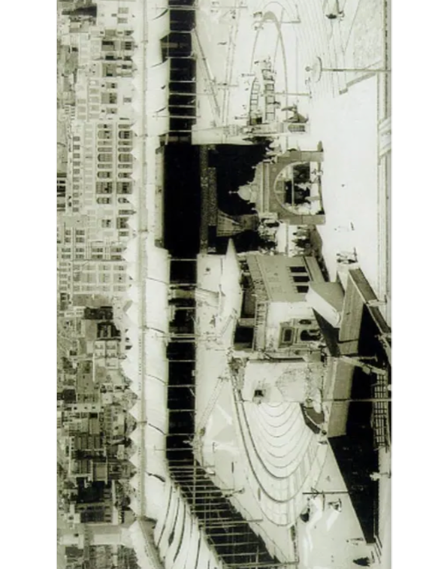
Historische Aufnahme des Zamzam-Brunnens im Bereich des Masjid al-Haram in Mekka.
Quelle: Islamic Landmarks, „Zamzam Well“, abrufbar unter:
https://www.islamiclandmarks.com/makkah-haram-sharief/zamzam-well
(abgerufen am 06.05.2026).
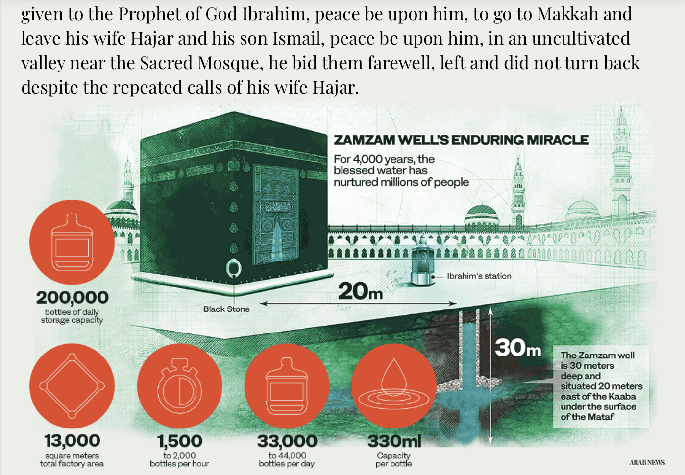
Abbildung X: Infografik zum Zamzam Water Project. Quelle: Arab News (2022), „Makkah’s Zamzam water production melds ancient history with modern technology“, URL, abgerufen am 06.05.2026.
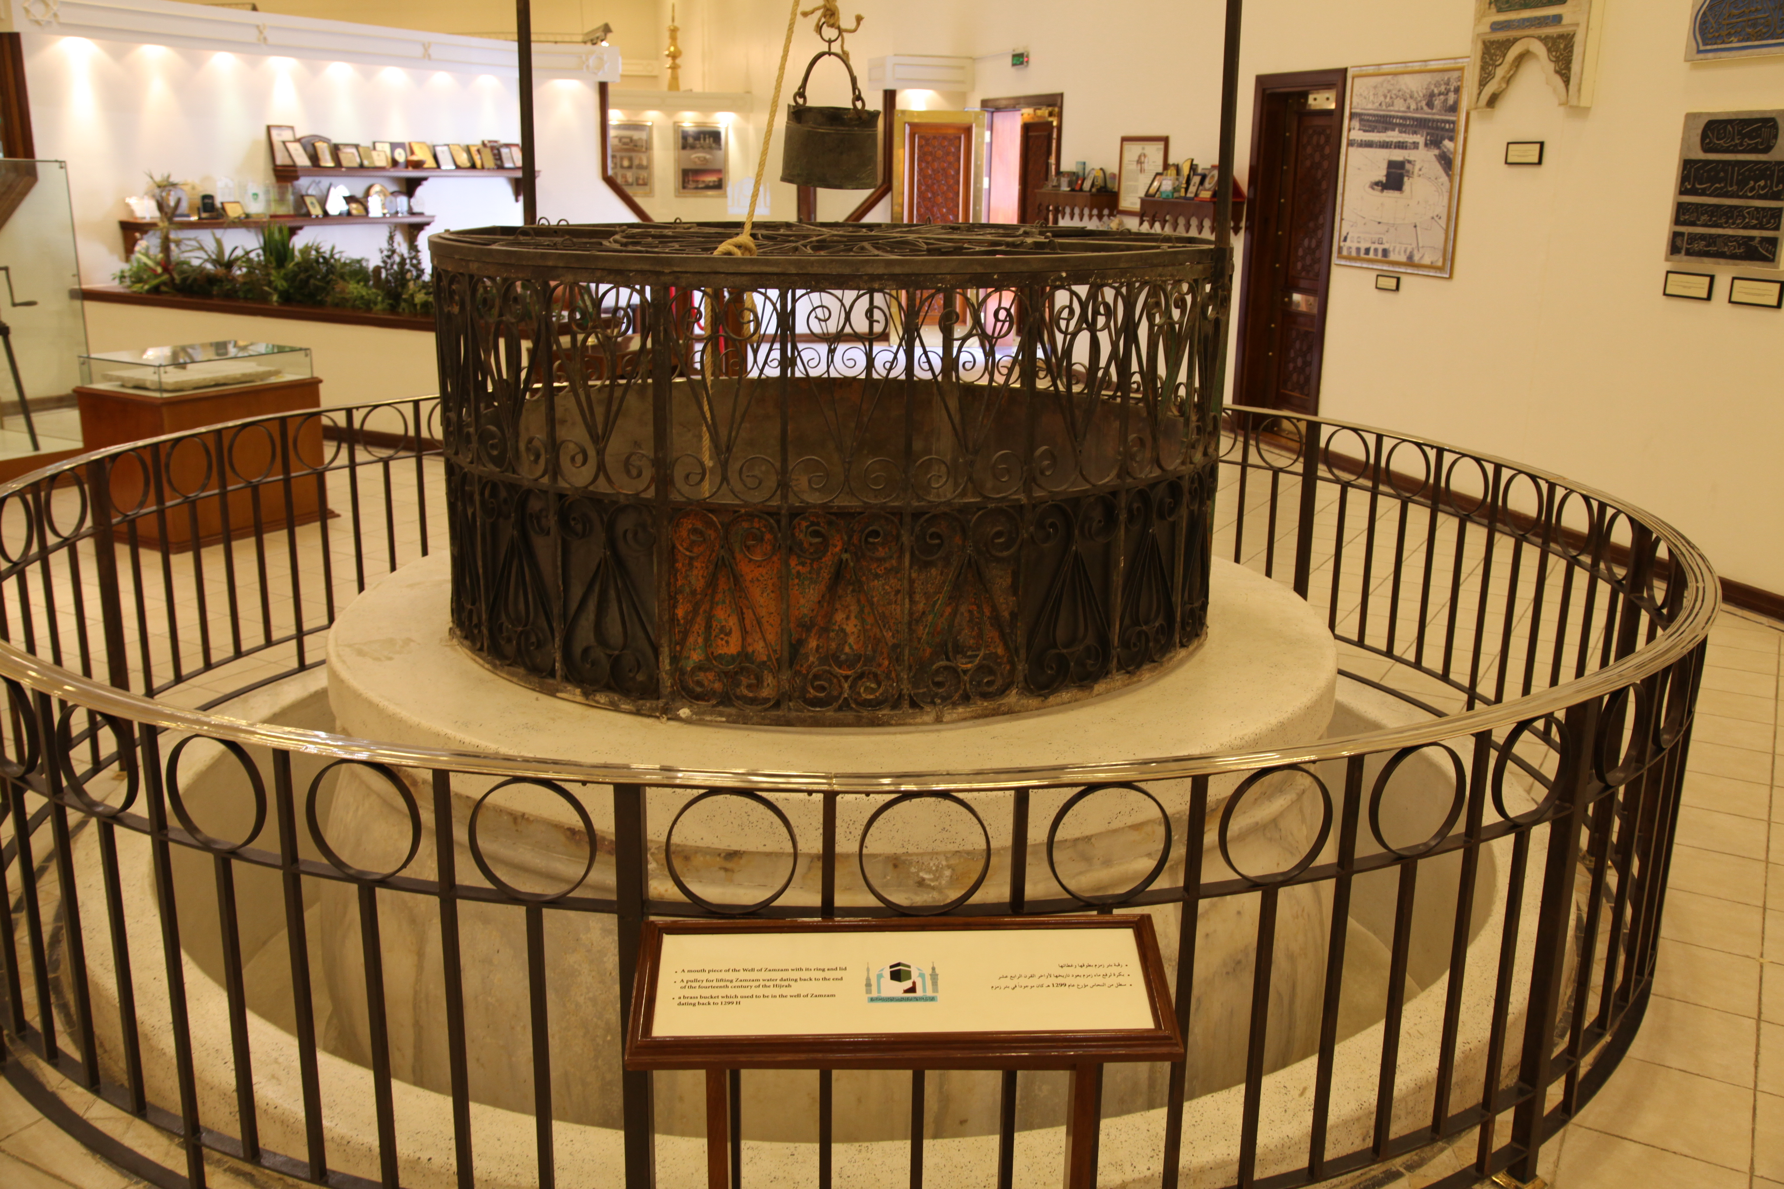
By Mohammad Bahareth - Flickr: بئر زمزم الأثري, CC BY-SA 2.0, https://commons.wikimedia.org/w/index.php?curid=33477990

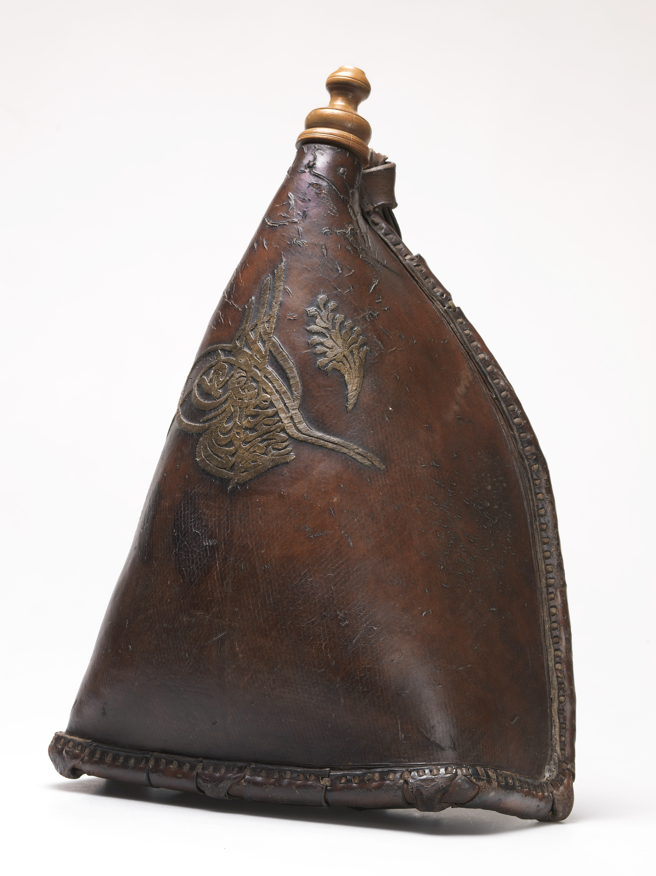
By Khalili Collections, CC BY-SA 4.0, https://commons.wikimedia.org/w/index.php?curid=97920328

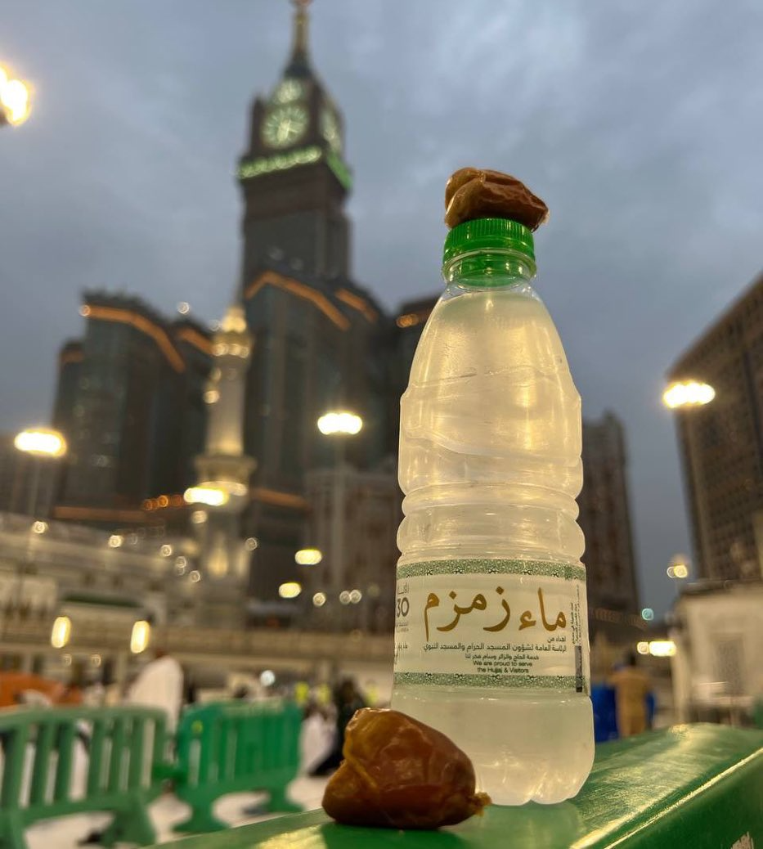
Source: Qamar, Mohammad Anees: Zamzam water bottle with dates in front of Abraj Al Bait Clock Tower, Mecca, via Wikimedia Commons, licensed under CC BY-SA 4.0, available at:
https://commons.wikimedia.org/wiki/File:Zamzam_water_bottle_with_dates_in_front_of_Abraj_Al_Bait_Clock_Tower,_Mecca.jpg (accessed: May 5, 2026).

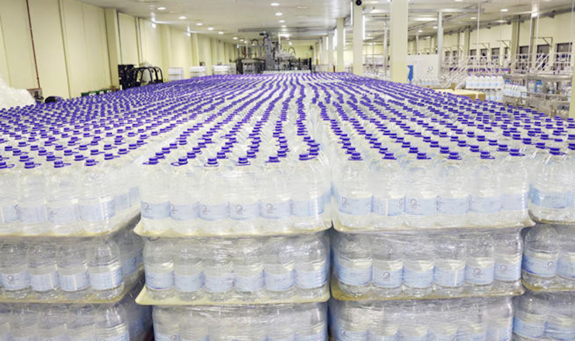

Image source: Arab News (2019): Changes to Zamzam bottles to meet demand. Online verfügbar unter: https://www.arabnews.com/node/1457111/saudi-arabia (Zugriff: 06.05.2026).
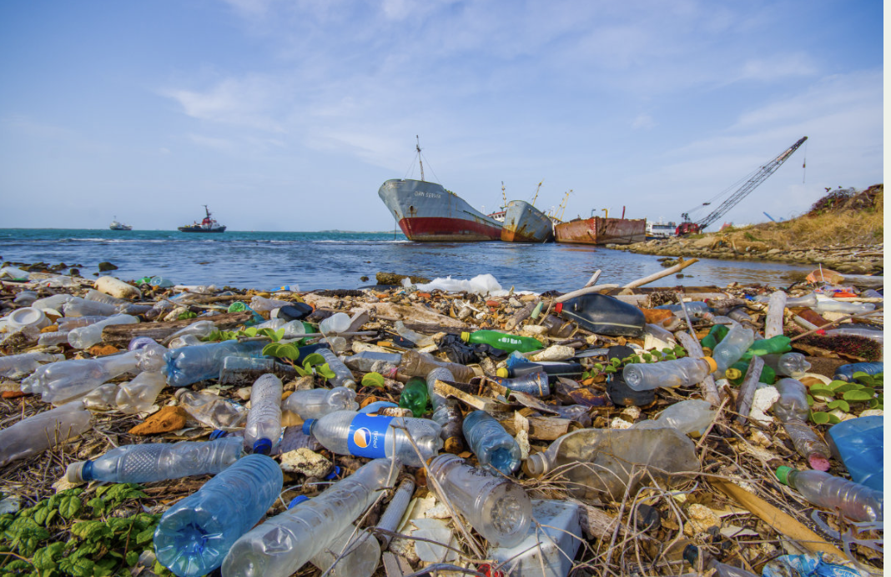
Image: Plastic waste on a beach because of global consumption patterns
Source: Shutterstock (stock image), cited from: Manal Al-Barakati, Why Saudi Arabia is ditching plastic bottles in favor of tap water, Arab News, 28.02.2025, https://arab.news/meu38 (Zugriff am: 05.05.2026)
The commercialisation of religious products is also evident in online retail. Zamzam water is sold internationally via platforms such as eBay in a variety of packaging and sales formats.
An example of the digital marketing of Zamzam water via international online retail platforms.
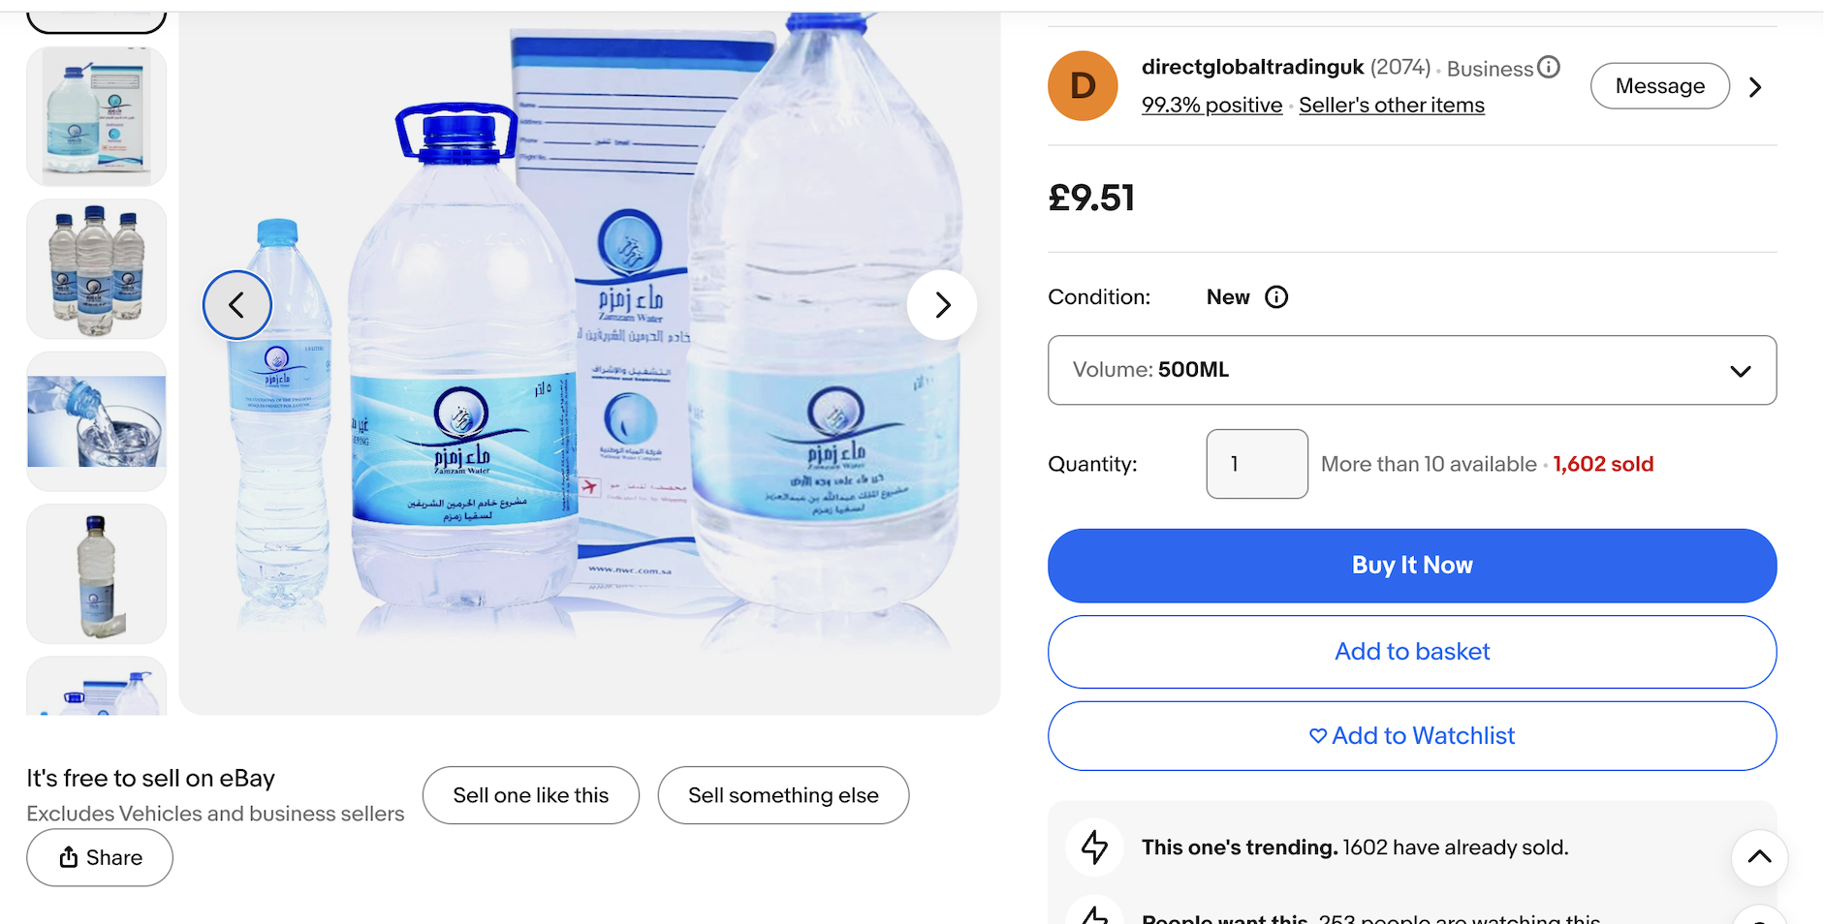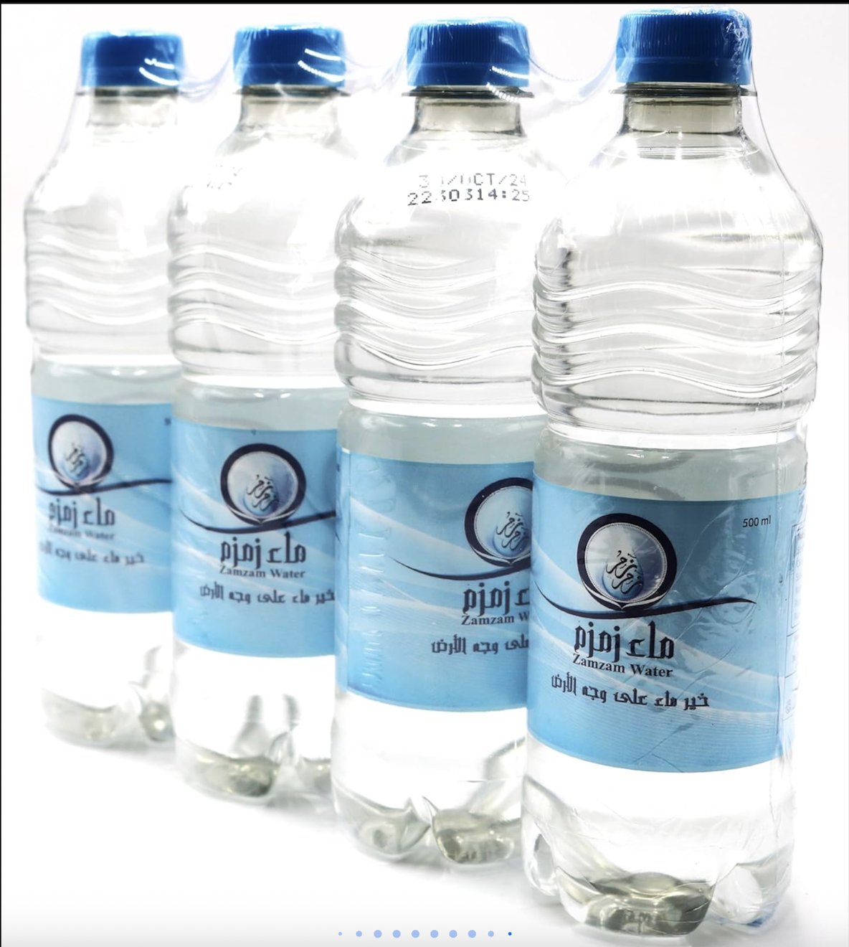
Source: eBay UK, „Zamzam Water Zam Zam Mecca Makkah 100% Original Natural“,
abrufbar unter:

https://www.ebay.co.uk/itm/235286049815 (accessed on 06.05.2026).

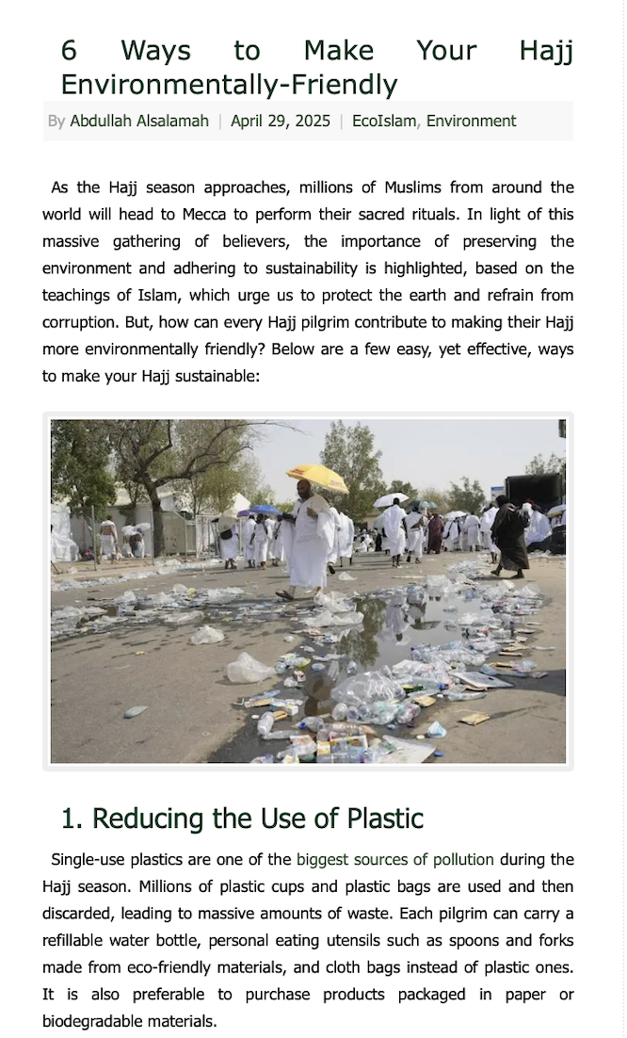
„6 Ways to Make Your Hajj Environmentally-Friendly“
The photograph highlights the environmental challenges posed by large-scale pilgrimages, particularly those caused by single-use plastics and water bottles. At the same time, there is a growing number of initiatives promoting a more sustainable and environmentally friendly Hajj (‘Green Hajj’), which call for waste reduction, recycling and responsible consumption.

Source: EcoMENA, „6 Ways to Make Your Hajj Environmentally-Friendly“, 29.04.2025,
https://www.ecomena.org/eco-friendly-hajj/
(accessed on 06.05.2026).

Article: Practical Solutions for a Waste-Free Hajj:
As Hajj season arrives, the waste crisis in Makkah necessitates eco-friendly practices: https://muslimclimatewatch.com/practical-solutions-for-a-waste-free-hajj/?utm_source=chatgpt.com

